Project Design Phase-I
Solution Architecture

Date | 14 October 2026
Team ID | -
Project Name | Health360-Healthcare-Analytics
Maximum Marks | 4 Marks

Solution Architecture
Solution architecture is a structured process that connects business requirements with an appropriate technical solution. It defines the system's components, their relationships, data flow, and the technologies used to develop and deliver the solution. For Health360, the architecture is designed to transform healthcare data into meaningful visual insights through Tableau Public.
The main goals of the solution architecture are to:
- Identify an appropriate technology solution for healthcare data analysis and visualisation.
- Describe the structure and interactions of the components used in the Health360 project.
- Define the data preparation, analytical workflow, and dashboard development process.
- Specify the technologies and resources required to develop, test, document, and deliver the solution.
- Present healthcare analytics findings in a clear and accessible format for users.

Solution Architecture Diagram: Health360 Healthcare Analytics System
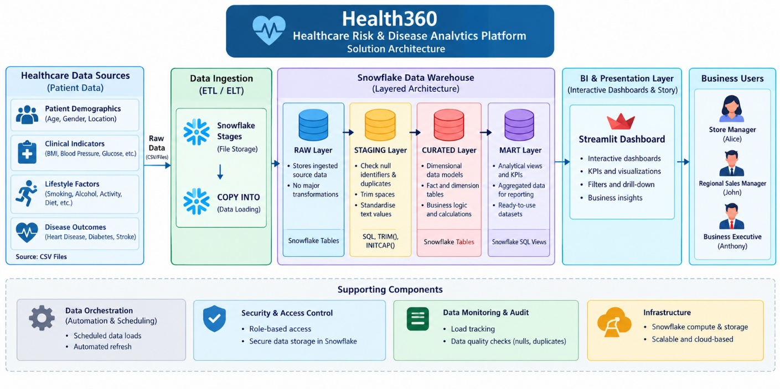
Figure 1. Solution Architecture of Health360: Comprehensive Healthcare Risk & Disease Analytics
The Health360 architecture begins with a healthcare dataset stored in CSV format. The dataset is connected to Tableau Public, where the available fields and data types are examined and the data is prepared for analysis. Tableau worksheets are then developed to explore patterns associated with heart disease, diabetes, and stroke. These worksheets are combined into interactive dashboards and a Tableau Story to communicate the analytical findings.
GitHub supports project documentation and versioned sharing of appropriate deliverables. The architecture reflects the planned Tableau-based workflow; additional components, such as Flask integration, are included only if required by the final project specifications.

Component Description Table
Component Name | Description / Role in Architecture | Technology Used
Healthcare Data Source | Provides patient demographic, clinical, lifestyle, and disease outcome information for analysis. | CSV dataset
Data Connection | Connects the healthcare dataset to Tableau and makes its fields available for analysis. | Tableau Public, CSV connector
Data Preparation | Supports inspection of data types, missing values, duplicate records, and inconsistent categories. Appropriate corrections are applied where necessary. | Tableau Data Source page, Tableau data preparation features
Analytical Worksheets | Explore disease distributions and compare available demographic, clinical, and lifestyle variables with recorded disease outcomes. | Tableau worksheets
Dashboard Layer | Combines related visualisations into interactive dashboards with relevant filters and summary indicators. | Tableau dashboards, filters, calculated fields where applicable
Tableau Story | Organises selected visualisations into a sequence that communicates the analysis and its key observations. | Tableau Story
Presentation Layer | Makes the completed dashboards and analytical findings available for review and presentation. | Tableau Public
Project Documentation | Records project objectives, methodology, data preparation, visualisations, testing, findings, and limitations. | Documentation files, Microsoft Word or PDF
Version Control and Project Repository | Stores the README, suitable project files, dashboard screenshots, and supporting documentation. | GitHub
Project Users | Healthcare analysts, clinical risk officers, and public health researchers can use the visualisations to explore patterns in the supplied dataset. | Tableau dashboards and Story

Data Flow
The Health360 solution follows a sequential analytical workflow:
- Data Input: The healthcare dataset is provided as a CSV file.
- Data Connection: The CSV file is connected to Tableau Public.
- Data Inspection and Preparation: Available fields, data types, missing values, duplicate records, and category consistency are reviewed.
- Exploratory Analysis: Relevant variables are examined to explore patterns in heart disease, diabetes, and stroke outcomes.
- Worksheet Development: Appropriate charts and calculations are developed using the available dataset fields.
- Dashboard Development: Related worksheets are combined into interactive dashboards.
- Story Development: Selected visualisations are arranged into a structured Tableau Story.
- Testing and Documentation: Dashboard functionality, calculations, usability, and performance are evaluated, and the findings are documented.
- Project Delivery: The final workbook and appropriate supporting files are organised in the Health360 GitHub repository. The workbook may also be published to Tableau Public when data-sharing conditions permit.

Architecture Benefits
- Centralised Visual Analysis: Presents relevant healthcare data in a structured analytical environment.
- Interactive Exploration: Enables users to explore available data through dashboard interactions and filters.
- Comparative Insights: Supports comparisons of disease outcomes across relevant patient characteristics when the necessary fields are available.
- Clear Communication: Uses dashboards and a Tableau Story to communicate observations effectively.
- Maintainable Deliverables: Organises the workbook, screenshots, and documentation for easier project review and future updates.
- Responsible Interpretation: Encourages exploratory analysis while recognising that associations in the dataset do not establish causation or provide individual medical diagnoses.
The architecture is intended for exploratory healthcare analytics and educational use. Its final implementation depends on the variables available in the supplied dataset and the confirmed requirements of the project.

